ENDURANCE POTENTIAL 2026 PROJECT
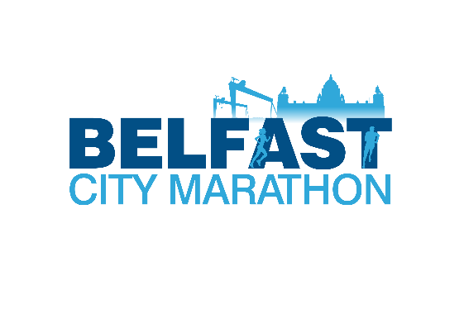

APPLICATION PACK- 2023

Athlete-Coach pairs should meet to complete the form below and return by email or post to mark.kirk@athleticsni.org by 21st May at 6pm. Questions can be emailed to mark.kirk@athleticsni.org.

To apply for the Endurance Potential 2026 Programme for 2023 please answer all questions below and tick all applicable boxes.

My Profile

Name:
Date of Birth:
Athletics Club:
Lead Coach:
Other coaches:

Main distance | Secondary distance
2020 PB: date; | 2020 PB: date;
2021 PB: date; | 2021 PB: date;
2022 PB: date; | 2022 PB: date;
2023 PB: date; | 2023 PB: date;

Best cross country/mountain running results:

Track and Road Achievements

3000m personal best (date/location) ……...

5000m/5k road personal best (date/location) …………………………………………………….

10,000m/10k road personal best (date/location) …………………………………………………..

Half Marathon personal best (date/location) ……………………………………………………….

Marathon personal best (date/location) ……………………………………………………………..

Other Achievements:

Current training mileage and/or typical sessions.
Easy runs
Steady runs
Threshold runs
Sessions
Gym sessions
Cross training

How many years have you been training for endurance? ……………….

General Preparation Typical Week Average Mileage
Date FROM and TO:

 | Mon | Tue | Wed | Thurs | Fri | Sat | Sun
AM
PM

Number of sessions completed with your coach present in a typical week:

My Injury History
Please list any injuries you had since January 2022 and number of training days lost through this injury or competitions missed. If you know the name of the injury, please include it and the name of your physiotherapist if you attended one.

Additional Sources of Funding
Please list any additional sources of funding you have received since September 2022 such as council grants, Mary Peters Trust or other types of sports bursaries.

My Eligibility
How are you eligible to represent Northern Ireland & Ulster? Please tick one box.
- Born in NI
- One or more parents born in NI
- One or more grandparents born in NI
- Three+ years residence in NI
- From one of the nine counties of Ulster

Please complete the paragraphs below

Athlete Statement
My short-term goal in endurance running is…

My long-term goal in endurance running is..
Evidence that I am tracking towards Commonwealth Level or above..

I feel the Programme would benefit me because…

Coach Statement:
In order to bridge the gap from current performance level to Commonwealth Games standard level I feel this athlete needs to……

I feel the most beneficial aspects of the Endurance Development Programme for this athlete will be……

My own areas for development as a coach are……

After review of applications received by 21st May at 6pm there will be a selection process and successful applicants will be contacted and made an offer of Endurance Potential 2026 Programme support for 2023. Details of training, education and competition opportunities will be confirmed at that time.

Once an offer is made to athletes, they will be able to assess that offer and their availability to the training and competitions.

Applications may be typed or handwritten but must be either emailed to mark.kirk@athleticsni.org or posted to arrive by 6pm on 21st May to:

Endurance Potential 2026 Programme
Athletics Northern Ireland
Athletics House,
Old Coach Road,
Belfast
BT9 5PR

Athletics NI intend to communicate with all applicants by 15th June 2023

